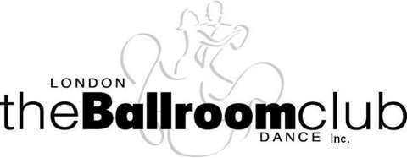
_{Lesson Sign-up Form}
Session 2 2025/2026 Season
Quickstep and Rumba

Level 1 (Beginner’s)

This level is for people who have never taken dance lessons or, have very little dance experience.

Level 2

This level is for people who are advancing from Level 1 (Beginner’s) or who do not fall into Level 1 but are not ready for Level 3.

Level 3 (If enough interest)

This level is for people who are advancing from Level 2 or are ready for more than Level 2.

Note * - Level 2 and 3 run together from 7 to 8 pm
- Level 1 runs from 8 pm to 9 pm

All classes are for 4 weeks starting on October 22nd at Banting High School
Lesson fee is $40.00 per person for the 4 week session for members and $50.00 for non-members.

Though we certainly welcome singles we cannot guarantee a partner.

All fees are non-refundable and payable in advance via e-transfer to Treasurer@lbdc.ca
If you have any questions or wish to pay by cheque please contact us.
All forms must signed and returned to londonballroomdanceclub@gmail.com

Print Name---------------------------------------------- Print Name---------------------------------------------

Sign--------------------------------------------------------Sign-------------------------------------------------------

Phone # ------------------------------------------------Phone #--------------------------------------------------

